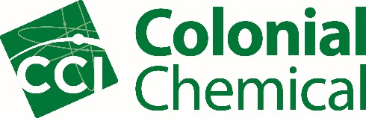

Senior Product Applications Chemist

Colonial Chemical Inc., a growing specialty chemical manufacturer, is seeking a Senior Product Applications Chemist. This position, reporting to the Research and Development Manager, will be responsible for overseeing a group of chemists and is responsible for advancing formulation expertise across multiple end-use categories. They work cross-functionally to design experiments and analyze data to produce effective sales tools and communicate that information to customers. The successful candidate will utilize market expertise to develop new products, formulations and product claims. They will attend a variety of trade shows/conferences to promote products and communicate findings.

The successful candidate must have a bachelor's degree from an accredited college or university, and 5 years of previous formulation experience. The candidate must have a strong working knowledge of surfactants and associated formulation science. The successful candidate must have knowledge of formulation concepts for multiple markets (PR, HI&I, oilfield, and more). Ability to work with minimal direction and guidance is a must. Must be flexible and able to change quickly with a fast-paced environment. Must have strong written and verbal communication skills.

Colonial Chemical is located at 225 Colonial Drive, South Pittsburg, TN 37380.

Please apply online at https://colonialchem.applicantpro.com/jobs/808253.html
You can also send resumes to carmen.ohagan@colonialchem.com

